Business Question and Visualization Report
Date | 18-09-2026
Team ID | MCA
Project Name | Smartphone Usage, Digital Addiction & Well-Being Analytics
Maximum Marks | 5 Marks

Visualization development refers to the process of creating graphical representations of data to facilitate understanding, analysis, and decision-making. The goal is to transform complex datasets into visual formats that are easy to interpret, enabling users to gain insights and make informed decisions. Visualization development involves selecting appropriate visual elements, designing layouts, and using interactive features to enhance the user experience. This process is commonly associated with data visualization tools and platforms, and it plays a crucial role in business intelligence, analytics, and reporting.
Business Questions and Visualisation
The process involves defining specific business questions to guide the creation of
meaningful and actionable visualizations in Power BI. Well-framed questions
help in identifying key metrics, selecting relevant data, and building visualisation
that provide insights.
1. What is the daily baseline user interaction regarding notifications and application engagement? | Visualization: KPI Cards tracking the overall average of daily app opens (97.83) and daily notifications received (134.26) | 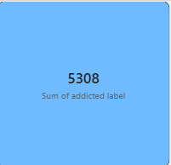
2. How does smartphone addiction distribution compare across different gender demographics? | Visualization: Clustered horizontal bar chart showing user count classified by addiction severity level (None, Mild, Moderate, Severe) and segmented by gender. | 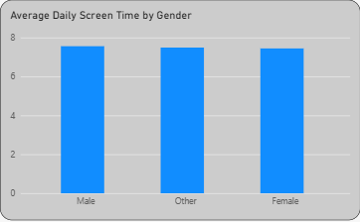
3. Does perceived academic work impact correlate with a change in average work or study hours? | Visualization: Horizontal bar chart comparing the average hours dedicated to work/study against the academic work impact status ("Yes" vs "No"). | 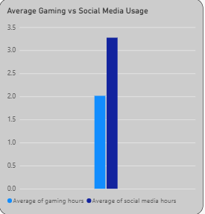
4. What is the explicit relationship between a user's addiction tier and their weekend screen time? | Visualization: Horizontal bar chart analyzing theescalation of average weekend screen time across addiction  levels,highlighting the jump to 10.4 hours for severe cases. | 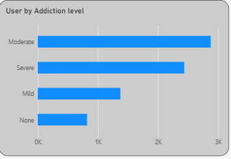
5. How does weekend screen time trend as user age groups shift? | Visualization: Line chart demonstrating the downward trend of weekend screen time from the 20–29 age bracket down to the under-20 cohort. | 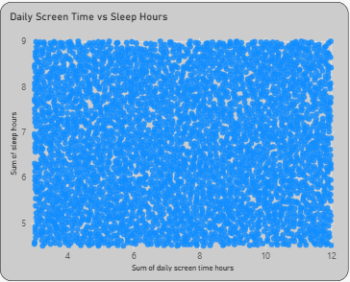
6. What proportion of the monitored population falls into high, medium, or low stress levels? | Visualization: Donut chart breaking down the total user base (7.5K users) by percentage share of high, medium, and low stress markers. | 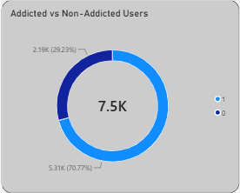
7. Is there a detectable trend or drop in average sleep hours across different adult age categories? | Visualization: Line chart mapping the negative trajectory of sleep hours from the 20–29 age group down to the 30–39 demographic. | 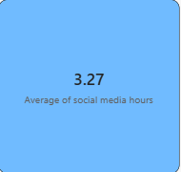
8. What specific metrics serve as the primary top influencers increasing the likelihood of digital addiction? | Visualization: Key Influencers visual identifying the statistical weight of daily screen time expansions and social media hours on an "Addicted" classification status. | 